CONGRATULATIONS on your new CAEP Accreditation! You are among a select group of providers recognized for excellence in preparing our next generation of teachers this fall. We are excited to help you maximize your exposure and promotional potential with future candidates and other stakeholders.

We compiled this communications toolkit to give you the resources and tools needed to spread the word about your accreditation.

If you have questions, please contact Matt Vanover at matt.vanover@caepnet.org, or 217-341-3849. Good luck!

EPP ACCREDITATION TOOLKIT RESOURCES
We have packaged all your Educator Preparation Provider (EPP) accreditation to meet CAEP’s recommended branding guidelines. At this link you will find: http://caepnet.org/PromoteAccreditation.
- Sample press release
- CAEP accredited logos and badges
- Standard CAEP logo
- CAEP logo style guide

We also include below a number of resources and suggestions for your websites and social media handles.

WHAT IS CAEP ACCREDITATION – AND WHY DOES IT MATTER?
CAEP is the only national accreditor for education preparation recognized by the Council for Higher Education Accreditation since its inception. We believe in striving for excellence in educator preparation, and we advance equity and performance through evidence-based reviews that promote quality and continuous improvement.

Visit this link at our website for a more detailed description: http://caepnet.org/accreditation/about-accreditation/what-is-accreditation.

Essentially, accreditation is the ultimate stamp of approval, from your peers, that your institution is meeting institutional and professional standards in preparing teachers. The ongoing national teacher shortage is clear proof that tomorrow’s teachers must be highly prepared and adaptable in the classroom. “Degree mills” and “accreditation mills” do nothing to prepare teachers for success, but simply add to the existing shortage.

Now, your institution has the CAEP seal of approval that your education preparation program is hitting the mark. If potential candidates ask about your accreditation status, you can proudly tell them you have CAEP’s approval. You should share this with academic advisors and faculty and explain what this designation means.

The University of North Georgia shares here its experience on the value of earning CAEP Accreditation: https://ung.edu/news/articles/2021/12/college-of-education-earns-accreditation.php.

SPREAD THE WORD ONLINE
CAEP is active on three social media platforms: Facebook, Twitter, and LinkedIn. We encourage you to follow us and engage with us as we work collaboratively to promote your exciting accreditation news:
- https://www.facebook.com/profile.php?id=100083190917026
- https://twitter.com/caepupdates
- https://www.linkedin.com/company/council-for-the-accreditation-of-educator-preparation-caep-/

The following are some suggested social media and website posts to make it easy to share your good news. Use these hashtags and tag CAEP where possible.

Facebook
- We are proud to announce the [EPP Name] has earned national accreditation by demonstrating excellence in the areas of content and #pedagogy, #clinicalpartnerships and practice, candidate recruitment, progression and support, program impact, and #qualityassurance and continuous improvement from the @Council for the Accreditation of Educator Preparation.
- [EPP Name] just earned CAEP accreditation for [number of years (usually seven)] years. @Council for Higher Education Accreditation.
- [EPP Name] is accredited based on the @Council for the Accreditation of Educator Preparation (CAEP) Standards through [year of accreditation expiration]. #CAEP is recognized by CHEA for educator preparation.

Twitter
- Becoming a great teacher starts with a strong educational foundation. We are accredited by @caepupdates. CAEP promotes excellence in #educatorpreparation through #qualityassurance and #continuousimprovement.
- [EPP Name] has earned national accreditation by meeting rigorous national standards for #educatorpreparation set by the @caepupdates.

LinkedIn
- The @Council for the Accreditation of Educator Preparation (CAEP) accredits [EPP Name]. CAEP promotes excellence in educator preparation through quality assurance and continuous improvement.
- [EPP Name] meets rigorous national standards for educator preparation set by the @Council for the Accreditation of Educator Preparation.

Website and brochure/publication
- The Council for the Accreditation of Educator Preparation (CAEP) accredits [EPP Name]. CAEP promotes excellence in educator preparation through content and pedagogy, clinical partnerships and practice, candidate recruitment, progression and support, program impact, and quality assurance and continuous improvement.
- [EPP Name] meets rigorous national standards for educator preparation set by the Council for the Accreditation of Educator Preparation.

OUR VISUALS
We ask that our accredited institutions follow some simple, important guidelines when using our CAEP logo to promote their accreditation:
- The online toolkit (also linked above) includes a logo, a badge and the standard CAEP logo for different uses
- We require our logo to be visible and legible, but its placement should be secondary to your branding
- Please do not modify our logo. Consult our CAEP Logo Style Guide for direction: http://caepnet.org/~/media/Files/caep/accreditation-resources/promote-accreditation/caep-logostyleguide.pdf?la=en

Here are examples of two logos you can use to promote your new status:

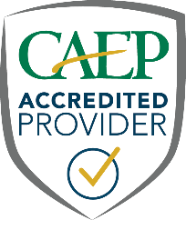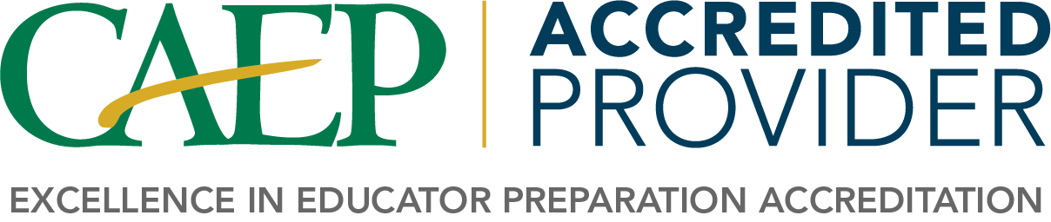

MEDIA OPPORTUNITIES
CAEP’s communications team is distributing a general press release acknowledging all of the new accredited institutions to outlets nationally. But we know local media often wants to hear from local voices.

We would encourage you to download from this Dropbox folder a draft press release you can localize and send out to your area media. Consider pitching your local media on talking with your institution about the importance of this accreditation announcement and connect them with faculty in your EPP who can talk about the practical ways they work every day to bring such positive recognition to your institution.

If you secure media coverage, let us know by tagging us when you share links on social media. You can also email us at communications@caepnet.org.

IMPORTANT PUBLIC DISCLOSURE
We must share this important reminder for all institutions on reporting performance data and other information:

Policy III.2.17 Restrictions on Communicating Accreditation Status; Correction of Incorrect or Misleading Information

An EPP awarded accreditation may elect to make its accreditation status public. In doing so, it must: (a.) Disclose the status accurately, including the specific academic or instructional programs covered by that status and CAEP’s name, address, and telephone number; (b.) Adhere to CAEP’s guidelines on communicating CAEP accreditation status, including terms and conditions on use of the CAEP logo; and (c.) Issue an immediate correction if made aware or otherwise determining that the information the EPP has released about the following is in any way incorrect or misleading: (i) The accreditation status of the EPP; (ii) The contents of reports of on-site reviews; and (iii) CAEP’s accrediting actions with respect to the EPP.

CAEP staff and Annual Report Reviewers review EPP statements of accreditation at least annually to ensure the accuracy of representation. A Review Team may also verify the accuracy of representations made and may note any misleading or inaccurate statements in a Site Review Report. If CAEP becomes aware that an EPP is not accurately reporting its accreditation to the public, the EPP will be contacted and directed to immediately issue a corrective communication. Failure to correct misleading or inaccurate statements may lead to Adverse Action.

Again, congratulations on your CAEP accreditation. Good luck with promoting this important accomplishment. If you have any questions, concerns or other feedback, please let us know: communications@caepnet.org.

The CAEP Communications Team

